Submitted By:

[Comments]| 691, Udyog Vihar, Phase v, Gurugram, Haryana- 122016



Solution Architechture Design



**Federal Mogul India**

**Warehouse Management System**

Ph.: 0124- 4337555

Document REVISION HISTORY

|  |  |  |  |  |
| --- | --- | --- | --- | --- |
| REVISION NO. | DATE | PREPARED BY | REVIEWED BY | COMMENT |
| 1.0 | 04-Jul-22 | Omkar | Rajeev Roy | Solution Architecture, Security Design, Authentication, authorization |

**Abbreviations:**

**Client:** Federal Mogul India, henceforth will be referred as FMI

**Vendor:** Bar Code India Ltd., henceforth will be referred as BCIL.

Notice:

This document contains information, which is the proprietary property of Bar Code India Ltd. This document is received in confidence and its contents cannot be disclosed or copied without the prior written consent of Bar Code India Ltd.

Nothing in this document constitutes a guaranty, warranty, or license, express or implied. Bar Code India Ltd disclaims all liability for all such guaranties, warranties, and licenses, including but not limited to: Fitness for a particular purpose; merchantability; not infringement of intellectual property or other rights of any third party or of Bar Code India Ltd; indemnity; and all others. The reader is advised that third parties can have intellectual property rights that can be relevant to this document and the technologies discussed herein, and are advised to seek the advice of competent legal counsel, without obligation of Bar Code India Ltd.

Bar Code India Ltd retains the right to make changes to this document at any time, without notice. Bar Code India Ltd makes no warranty for the use of this document and assumes no responsibility for any errors that can appear in the document nor does it make a commitment to update the information contained herein.

COPYRIGHT

Copyright © ***BCIL*** 2018. All rights reserved.

TRADEMARKS

*Other product and corporate names may be trademarks of other companies and are used only for explanation and to the owners' benefit, without intent to infringe.

Table of Contents

Introduction 1

Intended Audience and Reading Suggestions 1

Project Scope 2

User Interface Specification Conventions 3

Solution Architecture 4

Logical Architecture 5

Architectural Design 6

Communication Server 6

Device Application 6

Client Interface 6

# 

# Introduction

## Intended Audience and Reading Suggestions

The scope of this document is to provide the understanding of this solution to user & development teams associated with the application development & implementation.

This document major emphasizes on solution processes for Warehouse Management.

This solution will major comprises of followings:

* Desktop Application
* Mobile Device Application
* Communication Server Application

## Project Scope

The scope of the project is to create a WMS application using AIDC Technology (barcode labels and mobile computers) to efficiently monitor and manage the material movement and processing from RM Store to Production Floor. Material Identification will be done using barcode labels at the time of receiving.

The solution provides procedures to keep record of material during each stage when passed from RM to Production Floor and to Sub-Contractors for Job Work.

**RM Store:** The application will automate the warehouse processes i.e. Receiving, Palletization, Putaway and Issuing of material. Barcode Labels will be generated for the received material. Batch number, Product Code, etc. will be marked on label allowing user to trace the material at any stage. Material will be inspected & approved or rejected on the basis of quality check before being used for FG production. Material will be issued to production line against Production Order created on daily basis.

**Production Floor**: The solution will facilitate user to keep track of material consumed at each production line. Material will be packed in box and then in Master cartons to produce FG; barcode labels will be printed for each FG Carton in order to trace down the same on later stages.

**Job Work:** The application will also keep record of the material dispatched to Sub-Contractors or Vendors for SFG production against Production Order.

The solution is beneficial for Federal Mogul as it provides procedures for handling and managing returnable / non-returnable material, Sales Return Process, Stock Audit as well as tracking of material shipped to customers / other warehouse on zero value (Free of Cost).

This would require development of **Wi-Fi enabled application for real time transaction** i.e.the data will be captured in real-time, once the data has been collected, the database can then provide useful reports about status of material in warehouse.

The entire solution consists of followings:

* Desktop Application
* Mobile Device Application
* Communication Server Application

# Solution Architecture



**Note: -**

1. Coupon printing Scheduler is used to sync data from local to cloud.
2. Kitting Local database is connected with cloud server by linked server

# Logical Architecture

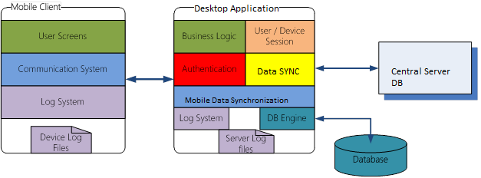

# Security Design

As BCI will not be using any web service and web API. All the application are windows application that are not exposed to web online so no security threat for application.

# Authentication and Authorization

Indeed every application is connected to the local database. Each user is connected with the application with a specific user and role. As application is connected with the specified user will be having specific rights. Password is encrypted and minimum 8 characters with alpha numeric is required.